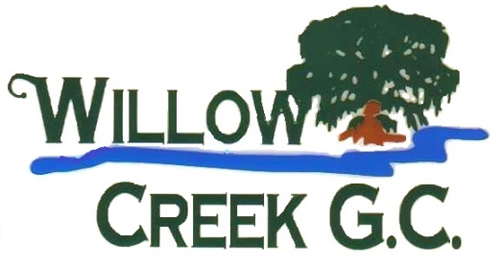
Individual 2021 Season Passes

Willow Creek Premier $1,100 (Limited Quantity Available)
- Greens Fees with Cart
- Weekdays (Anytime) & Weekends (after 12:00 PM)
- Includes League Play

Willow Creek Gold $800 (Limited Quantity Available)
- Greens Fees with Cart
- Weekdays Only

Willow Creek Silver $600 (Limited Quantity Available)
- Greens Fees – Walking
- Weekdays (Anytime) & Weekends (After 12:00 PM)

Willow Creek Bronze $400
- Greens Fees – Walking
- Weekdays Only

Willow Creek Junior - Plus $250
(Age 17 & Under)

- Greens Fees – Walking
- Weekdays (Anytime) & Weekends (After 12:00 PM)

Willow Creek Junior $200
(Age 17 & Under)

- Greens Fees – Walking
- Weekdays Only
*All Season Passes Exclude Outings

